*Florida International University*

*School of Computing and Information Sciences*

CEN 5011- Advanced Software Engineering

Feature Document

User Story #1158

# **Search name in admin panel**

**Team Member:**

Ravi Kiran Agarthi

**Product Owner(s)**:

Masoud Sadjadi

**Mentor(s)**:

Mohsen Taheri

**Instructor**: Masoud Sadjadi

# 

# 

# **User Story - Search name in admin panel**

● As a user, I would like to search the students in the list of Users available in the admin panel so that it would be feasible for quick navigation.

## **Use Case**

**Use Case ID:** (VIP-1158)

**Details:** Search name in admin panel

**Actor:** Pi/CoPi

**Pre-conditions:**

1. Pi/CoPi has navigated to the VIP website.

2. Pi/CoPi is able to login and click on admin panel.

3. Pi/CoPi is navigated to the admin panel page

**Description:**

1. Pi/CoPi should be able to use the search box in order to search for the students in the list.

2. If Pi/CoPi enters any student’s name in the search box then only their name should be visible in the list

**Post-conditions:**

1. Pi/CoPi should be able to click on the name of the student whom he just searched for the detail information

**Alternative Courses of Action:**

N/A

**Exceptions:**

N/A

**Related Uses Case:**

N/A

**Use Case Diagram**

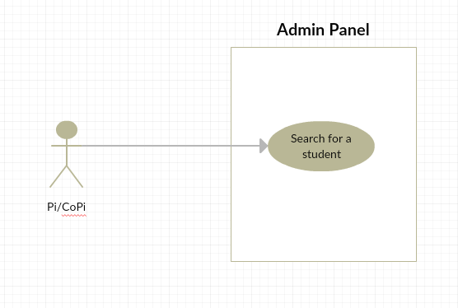

**Sequence Diagram**

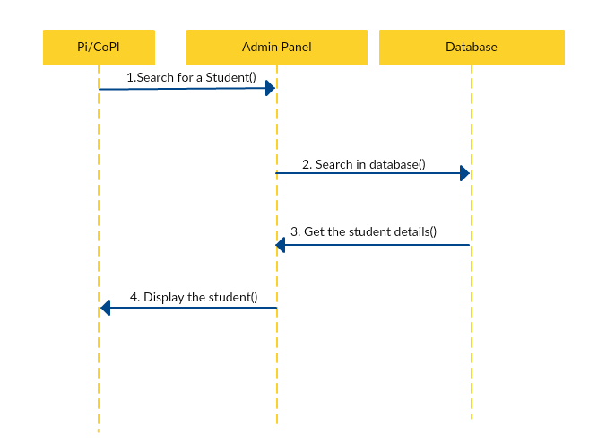

**Class Diagram**

N/A

**Unit & Integration Tests:**

## **● Test Case 1(Sunny Day)** ○ Purpose: Test that the search box above the list of users is working properly.

## ○ Precondition: Pi/CoPi has reached the VIP site and reached admin panel page.

## ○ Input: Pi/CoPi has to enter any user’s name or email etc who is in the list.

## ○ Expected Result: The list should show only that user’s name which Pi/CoPi is entered ○ Actual Result: The list shows only that user’s name which Pi/CoPi is entered. ○ Status: SUCCESS

## 

## **● Test Case 2(Rainy Day)** ○ Purpose: Test that the search box above the list of user is working properly.

## ○ Precondition: Pi/CoPi has reached the VIP site and reached admin panel page.

## ○ Input: Pi/CoPi has to enter any user’s name or college etc who is not in the list.

## ○ Expected Result: The list should not show any user’s name as the entered name is not in the list. ○ Actual Result: The list should doesn’t show any name as the entered name is not in the list. ○ Status: SUCCESS

## **Visual User Guide**

Admin Panel

